**OUTPUT SCREEN SHOTS WITH DESCRIPTION.**

**Home Page:**



**Fig2**: Home Page

**Load Data:**

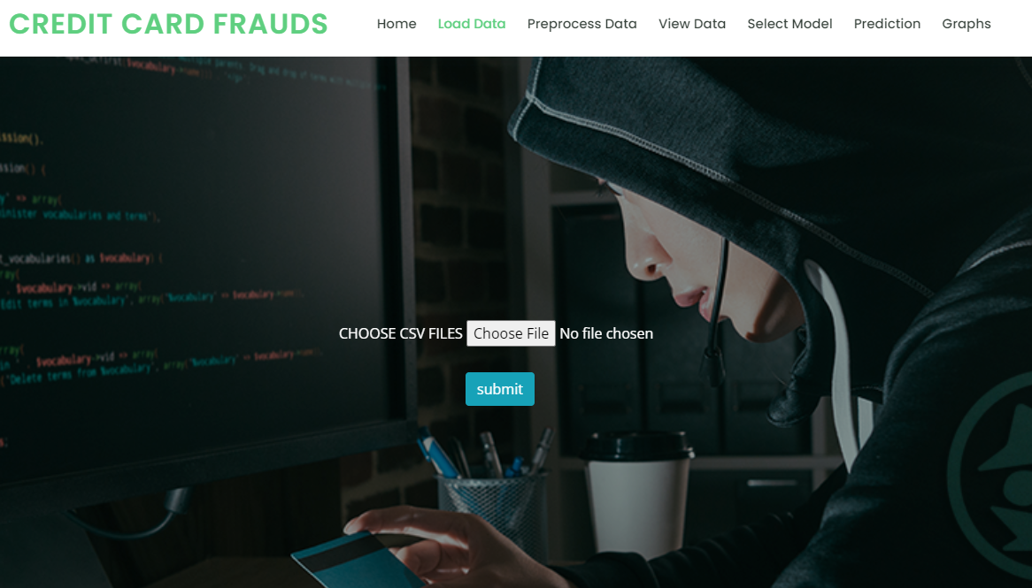

**Fig3**: Load Data Page

**Preprocessing:**



**Fig4**: preprocessing Page

**View Data:**

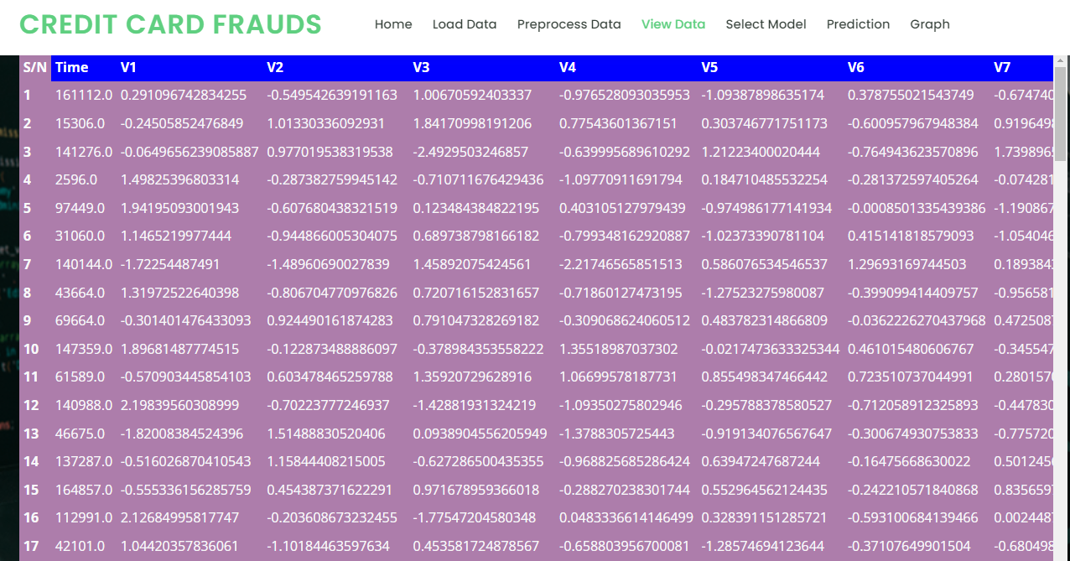

**Fig5**: View Data Page

**Model:**

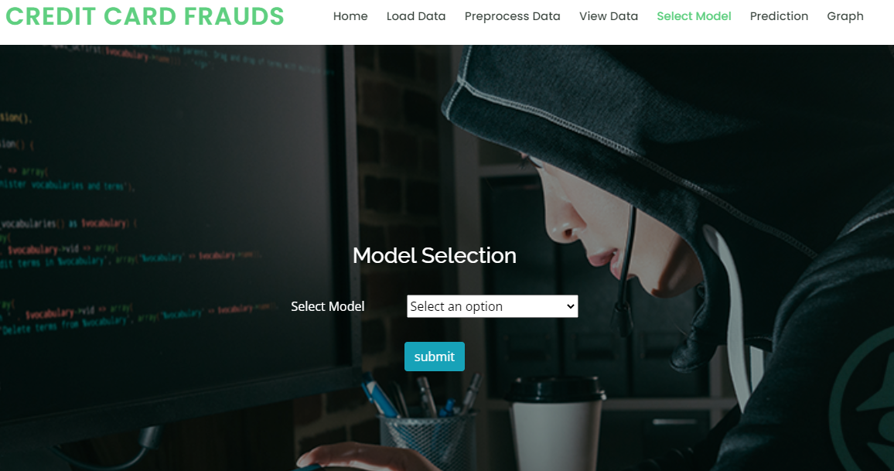

**Fig6**: Model Page

**Prediction:**

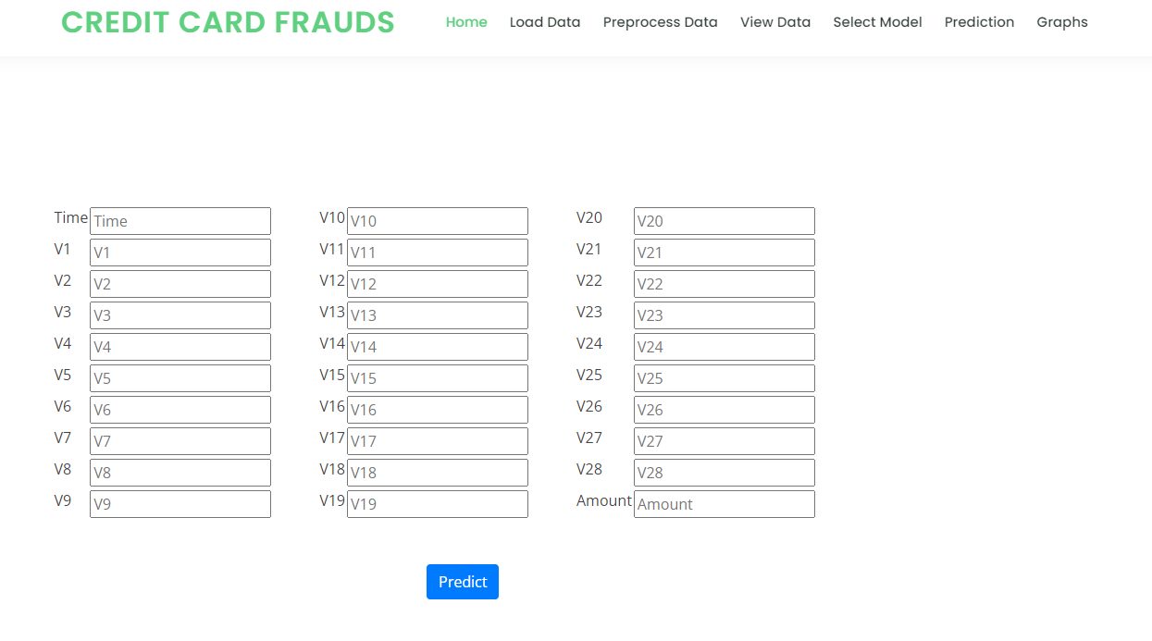

**Fig7**: Prediction Page

**Graph:**

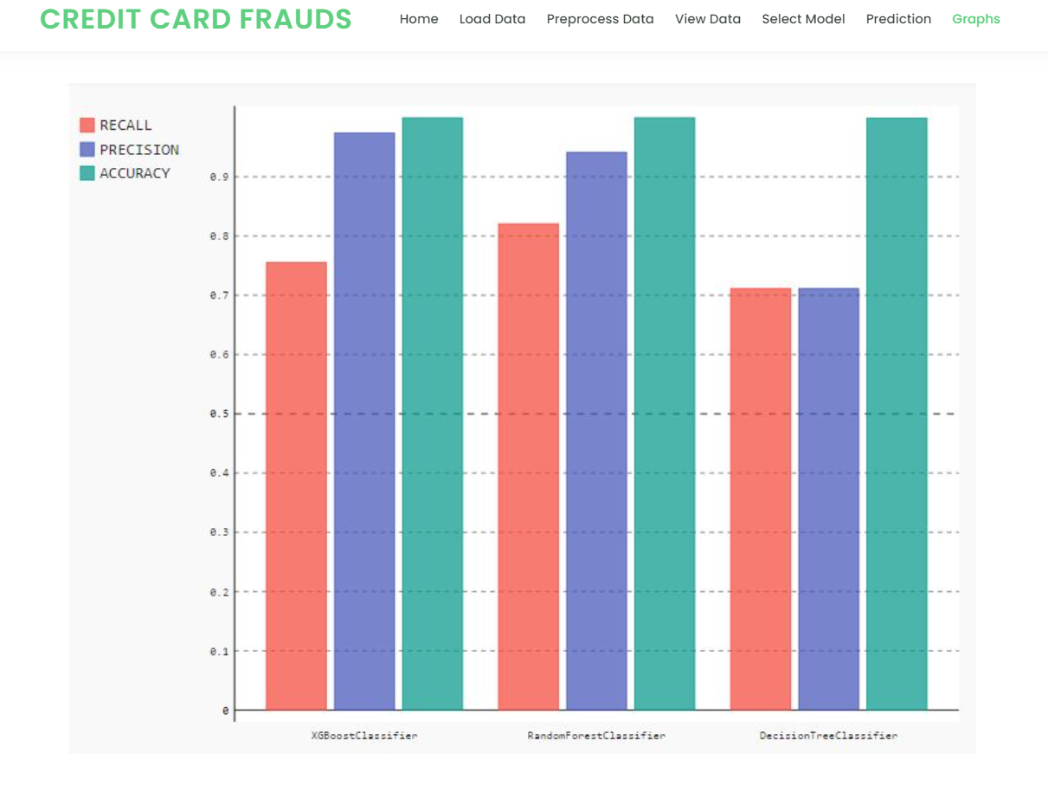

**Fig8**: Graph Page